# **The O.D.D. (Open Drone Detector) Manual**

O.D.D created by: Corneliu Sargarovschi, Brooke Hughes, Jonas Ciliento

Manual written by: Jonas Ciliento

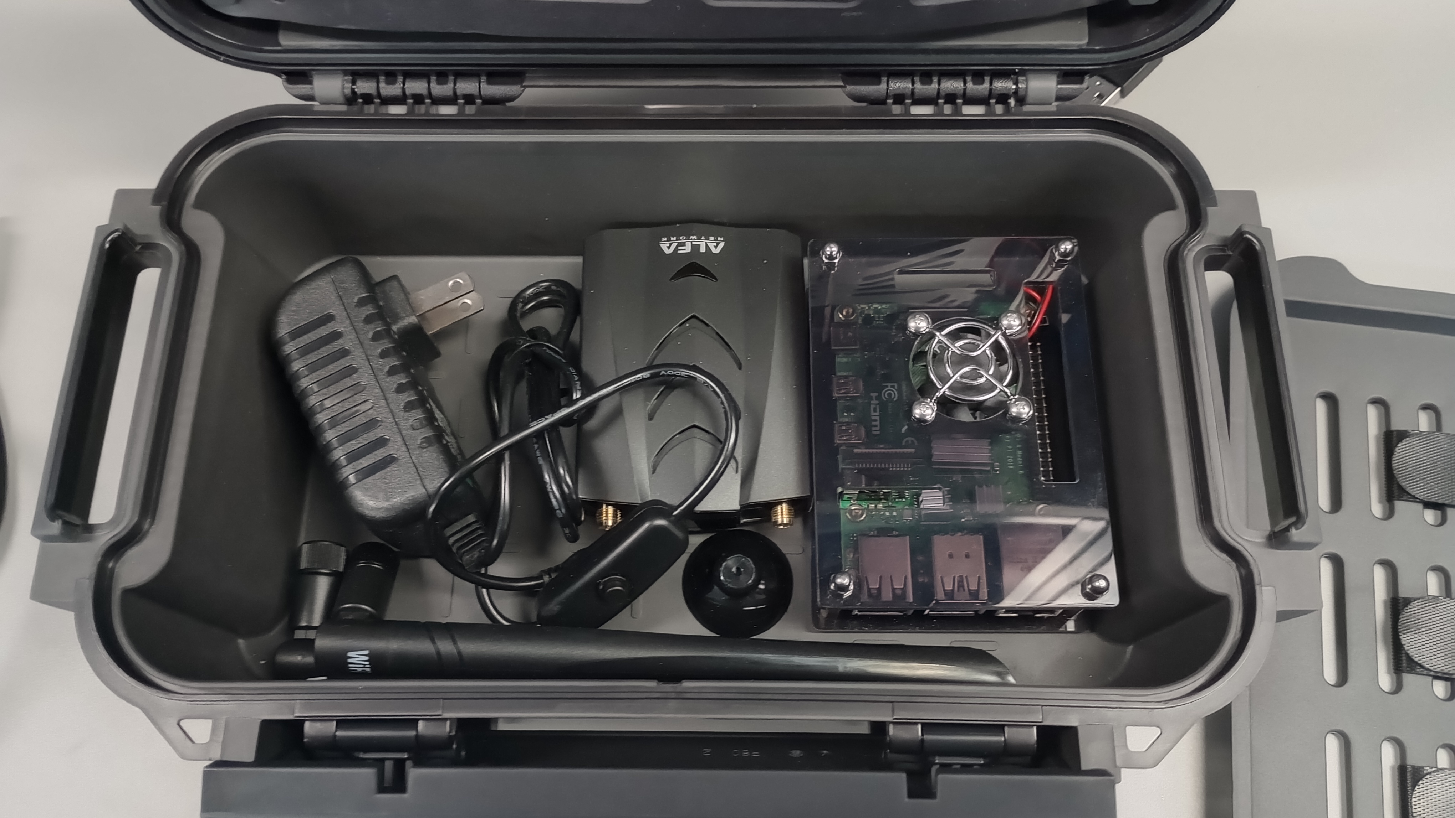

**What is this device?**

The O.D.D. is a drone detection device based on the Raspberry pi 4b, which scans for RemoteID signals that drones are required to output by law, and then condenses the contents of these signals into a .CSV file which can be integrated into GIS interfaces for easy viewing. The device is low cost, flexible, and easy to setup/store. This makes it an ideal solution for emergency services looking to track the location of a drone operator, identify noncompliant drones not broadcasting their RID signal, or identify their own drones in the field when many may be deployed at once.

**What is this manual?**  
 This manual is a detailed setup guide, and operations manual for the O.D.D. It is intended for an IT specialist or an otherwise computer literate personnel member to use to acquire, install, setup, and confirm the correct operation of the O.D.D. It contains detailed information on how to set it up, what commands to use, and what the commands are doing. Further information on how the code itself actually functions can be found in the comments inside of **shell_main_w_ch_swtch.sh.** This file is found within the program files. This manual also contains the bill of materials for the project, so that anyone interested in creating one of these systems for themselves, can buy the materials and do so.

**Bill of Materials**

1. (1) Raspberry pi 4b 4gb model
2. (1) MicroHDMI to HDMI cable
3. (1) USB-3.1 to USB-C cable
4. (1) Alfa Network AWUS036AXML wifi adapter with antennas
5. (1) GeeekPi nRF52840 Micro Dev Kit USB Dongle
6. (1) Raspberry pi 4b power supply adapter [5V 3A]
7. (1) Pelican R60-Large Ruck Case
8. (1) 32gb or larger microSD card with SD card adapter
9. (1) Separate working computer [For installation purposes]
10. (1) ISO of Kali Linux released later than 03/11/25 [M/D/Y]

**Hardware Setup guide**

1. Remove the raspberry pi, network module, antennas, power supply, and HDMI cable from the case.
2. Plug in the power supply, an external mouse and keyboard, network module with antenna, and a monitor to the raspberry pi. Ensure that the network module is connected to the blue USB ports on the raspberry pi, and the keyboard and mouse are connected to the black USB ports.
3. Sign in to the raspberry pi, by default on kali, the username is kali and the password is kali. If you change this, ensure you write down the new username and password.
4. If this is your first time setting up the device, move on to the ‘install’ section, otherwise consult the ‘Capture using script’ section

**Kali Linux Installation**

1. Process for installing kali linux on the raspberry pi is simple, first you will install the raspberry pi imager from the raspberry pi foundation website linked here [Raspberry Pi OS – Raspberry Pi](https://www.raspberrypi.com/software/)
2. Once downloaded, install the imager on your computer, and run it. It will open a window with 3 different boxes
3. Insert the microSD card you will use for the raspberry pi into your computer
4. In the first box, choose the model of raspberry pi you are using, the model chosen for this project is a raspberry pi 4
5. In the second box labelled “choose OS”, scroll down until you see the “other specific purpose OS” section, and click it. Once inside, find the “Kali Linux” option, and click it. Be sure you install the 64 bit version for raspberry pi 2, 3, 4, and 400. DO NOT SELECT THE 32 BIT VERSION.
6. Choose the microSD card you wish to flash with the OS, the imager will erase all data on the microSD card and replace it with the OS. WARNING: MAKE SURE YOU ARE FLASHING THE MICROSD CARD, AND NOT A DIFFERENT STORAGE DEVICE YOU HAVE PLUGGED IN, IT WILL ERASE ALL DATA ON THE DRIVE YOU TELL IT TO USE.
7. Once installed, remove the microSD card from your computer, and plug it into the raspberry pi’s microSD slot. This slot is on the underside of the board, it is the only slot on the underside of the board.
8. Turn on the pi, log in with username: kali password: kali
9. After logging in, you are free to change the username and password

Helpful Hint: To copy paste in the terminal window, press ctrl + shift + v in that order after copying the desired data.

**Software Install**

1. First you will download our program from github
2. Type ‘git clone --single-branch --branch main<https://github.com/ayumu-kasuga/remoteID_packet_reader_loop_script.git> ‘ in order to download the program and all necessary files. By default, it will place these files into /home/kali/remoteID_packet_reader_loop_script/
3. Type ‘sudo apt install xfce4-terminal' this is vital for the next steps
4. Once downloaded, type ‘chmod a+x /home/kali/remoteID_packet_reader_loop_script/packet_reader_script/shell_main_w_ch_swtch.sh’
5. Then type ‘chmod a+x /home/kali/remoteID_packet_reader_loop_script/packet_reader_script/drone_detection.desktop’
6. Afterwards, cut and paste ‘drone_detection.desktop’ into the desktop, and double click it to ensure it works and is installed correctly. Click “always trust”
7. You will then install QGIS for a local mapping system, in case there is no internet available
8. Type ‘sudo apt install gnupg software-properties-common'
9. Type ‘sudo add-apt-repository ppa:ubuntugis/ubuntugis-unstable’
10. Type ‘sudo apt install qgis python3-qgis qgis-plugin-grass
11. This will finish installing qgis
12. Next you will ensure you have the correct version of python, and other necessary components
13. Type ‘python3 --version’ in the term, this will confirm it’s installed
14. Type ‘sudo python3 -m pip install numpy ’ in the term, this will install numpy, a necessary library, if it’s not already installed
15. Type ‘lsusb’ to list what’s plugged into the USB ports, this will return the wireless adapter you are using, which should be the one listed in the BoM
16. Type ‘iwconfig’ to confirm the wireless adapter is working on wlan1
17. Type ‘sudo apt-get install aircrack-ng' to make sure aircrackng is installed. It will tell you if it is already installed
18. Type ‘sudo airmon-ng' to confirm installation
19. Type ‘sudo airmon-ng start wlan1’, will create a new interface wlan1mon
20. Type ‘iwconfig’ to make sure wlan1 is changed to wlan1mon

**Setup wireshark**

1. Type ‘sudo dpkg-reconfigure wireshark-common', when the prompt shows up, hit yes with enter
2. Type ‘sudo usermod –a –G wireshark kali’ adds the user to the group that can capture packages
3. Log out log back in
4. Type ‘wireshark’ to open the program
5. Click ‘help > about wireshark > folders’
6. Double click “Personal Extcap path”, and when prompted, create a folder.
7. Open up /home/kali/remoteID_packet_reader_loop_script/packet_reader_script/packet_capture/nRF Sniffer BLE/extcap
8. Put all files and folders in that filepath into the wireshark ‘personal Extcap path’ folder you created
9. Right click in file menu, select ‘open terminal here’
10. Type ‘python3 -m pip install –r requirements.txt --break-system-packages’ to install required plugins
11. Type ‘/home/kali/.local/lib/wireshark/extcap/nrf_sniffer_ble.sh --extcap-interface EXTCAP_INTERFACE’ this will add the sniffer to the interface, if you get an error message that the user can’t modify it, type ‘chmod a+x /home/kali/.local/lib/wireshark/extcap/nrf_sniffer_ble.sh’ to make it modifiable
12. Go back to wireshark ‘help > about wireshark > folders’
13. Click ‘Personal Lua Plugins’, make a new folder, copy in ‘opendroneid-dissector.lua’ and ‘bit32.lua’ from /home/kali/remoteID_packet_reader_loop_script/packet_reader_script/packet_capture/nRF Sniffer BLE/wireshark-dissector-main/ into the wireshark filepath you created
14. Go back to wireshark, press ctrl + shift + l to refresh the plugins
15. Restart wireshark
16. Click ‘help > about wireshark > plugins’, ‘opendroneid-dissector.lua’ should be in the list of plugins.

**Capture remoteid packets manually** [skip this unless you are interested in the specific steps the program takes to capture a packet, not required for function]

1. Type ‘iwconfig’ to make sure wlan1 exists
2. Type ‘sudo airmon-ng start wlan1’
3. Type ‘iwconfig’ again to make sure wlan1mon exists
4. Type ‘sudo iwlist wlan1mon channel’ to list all channels available on the wifi card
5. Type ‘sudo iwconfig wlan1mon channel “[channel number]” ‘ to list current channel
6. Type ‘sudo iwconfig wlan1mon freq “[frequency]”’ to change the frequency you are looking for signals on
7. Type ‘wireshark’ when on desired channel
8. Right click on ‘wlan1mon’ and click “start capture” to capture signals on that frequency/channel

**To capture using script**

1. Double click the file you copied to the desktop
2. This will open the terminal, and give you a few prompts they are generally self explanatory, but will be covered in detail here
3. The first prompt will ask if you want to use QGIS, if you type ‘y’ it will open it once the program starts
4. The second prompt will ask you if you want to update your coordinates, if you type ‘n’ it will go with the last coordinates it has saved. If you type ‘y’ you will need to enter in your current coordinates
5. The third prompt will ask if you want to use the default channel or not

Important note: While it is capturing packets, if no drones are in the area or the system has just started, various values will be replaced with “null.” This is entirely normal, and these values will be updated once data starts coming in.

**To sign in to ARCGIS and add the csv file as a layer**

1. Open Firefox
2. Go to ARCGISOnline
3. Click “sign in” and sign in with your organization’s credentials
4. Go to “content” and add the csv file using the filepath, set it to update every 30 seconds. (You are looking for the Drone_Array_V4.csv file in the program filepath)

**Add CSV file to layer**

1. Go to “my content”
2. Click “create new”
3. Click “add file”
4. Drag and drop CSV file to put it in the layer (You are looking for the Drone_Array_V4.csv file in the program filepath)

**Troubleshooting**

There are various issues which can crop up during the installation of an O.D.D. Unit, too many to list every single possible issue that can crop up however I will do my best to give a good general overview of how to troubleshoot. The way the manual is laid out gives you a guide of all steps strictly necessary to set up the system, if you encounter an error it can be because of one of two things; a previous step suffered an error, or an extra step was taken that caused new errors to be introduced. Out of the two possibilities, it is more likely the former is the culprit. This manual also presumes you are working with a brand-new install of kali linux on a brand-new raspberry pi, an existing raspberry pi installation or kali linux installation may suffer from additional issues caused by missing software dependencies or other existing problems with that raspberry pi. With this in mind, these are the generalized steps you should take for troubleshooting the system.

Step 1. Determine if all previous steps were done correctly, if so, move on to step 2.

Step 2. Look up the error you are suffering, it could be something as simple as an extra terminal input being necessary, but this is going to depend very heavily on the actual issue. It is recommended you only do this if you are familiar with Linux. If this doesn’t work, move on to step 3.

Step 3. type ‘sudo apt update’, then type ‘sudo apt upgrade’, this could potentially fix it, but it can also break other things. If this doesn’t work or breaks something else, move on to step 4.

Step 4. Create a fresh install of Kali Linux on the microSD card and start from the beginning, this is the nuclear option. If this still doesn’t work, install specifically the Kali Linux version released on 03/11/25 [MM/DD/YY] as this was the version confirmed to be working during the creation of the O.D.D.

Please keep in mind that these four troubleshooting steps are an extremely general list of things to do, it is highly recommended that if you run into issues you consult an IT specialist who will know how to troubleshoot in a more effective manner. There is no guarantee these four things will solve all problems, but it will hopefully assist in solving any issues encountered during the installation of the O.D.D. Our capstone team hopes that the device will serve you well, and help make the world a better place.